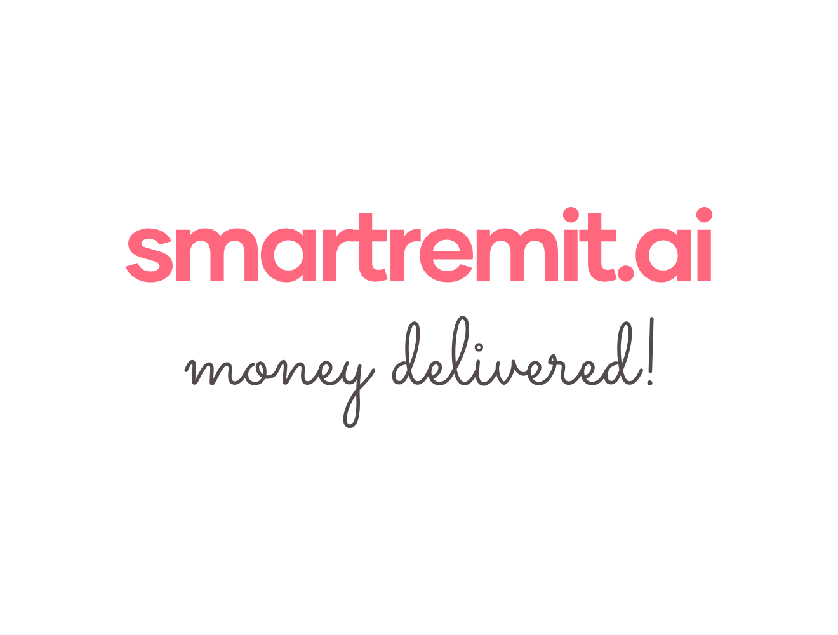SmartRemit AI Process Flows
1. User Onboarding and KYC
Step | Action
1 | The user opens WhatsApp and says they want to send money to India.
2 | AI checks whether the user is already registered.
3 | If new, AI sends a secure registration link.
4 | User completes ID/KYC in secure webview.
5 | KYC partner verifies identity and screening results.
6 | The User links to a bank account or card.
7 | AI confirms that the account is ready to send money.

2. Add Recipient
Step | Action
1 | The user says “Add Mom as recipient” or provides UPI/bank details.
2 | AI asks for any missing details.
3 | System validates UPI ID format or bank account/IFSC format.
4 | AI shows the recipient details for confirmation.
5 | The user confirms and the recipient is saved with a nickname.

3. Send Money
Step | Action
1 | The user says “Send $200 to Mom”.
2 | AI checks recipient, KYC status, limits, and funding source.
3 | The system fetches the exchange rate and calculates fee and INR payout amount.
4 | AI shows a clear quote and asks the user to confirm.
5 | The user confirms using a secure PIN, passcode, or biometric step.
6 | Funds are collected and routed through selected partners.
7 | India payout is initiated through UPI/IMPS or bank payout rail.
8 | AI sends completion confirmation on WhatsApp.

4. Track Transfer
Step | Action
1 | The user asks “Where is my money?” or “Track last transfer”.
2 | AI identifies the latest or selected transaction.
3 | The system checks the current transaction status.
4 | AI replies with the status, estimated time, and next step if needed.

5. Failed or Delayed Transfer
Step | Action
1 | The system detects failure, delay, incorrect details, or timeout.
2 | AI sends a clear message without exposing sensitive compliance details.
3 | Users are guided to retry, update recipient details, change funding source, or request refund.
4 | The support or compliance team reviews the case when manual action is required.

6. Voice Note Flow
Step | Action
1 | The user sends a voice note with payment instructions.
2 | Audio is converted to text.
3 | AI extracts intent, amount, currency, recipient, and frequency if mentioned.
4 | AI shows the interpreted instruction and asks the user to confirm before any money movement.

